|  |  |
| --- | --- |
| RAILWAY RESERVATION | **2012** |

**A**

**PROJECT REPORT ON**

RAILWAY RESERVATION SYSTEM

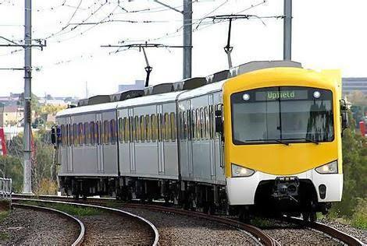

**PREPARED BY:-** **MOHD. ABDULLAH**

 **A A SHAKILLUDDIN AHMAD**

|  |  |
| --- | --- |
| RAILWAY RESERVATION | **2012** |



1. Acknowledgement
2. Introduction

3) Literature Review

4) Proposed methodology

5)Result and Discussion

6)Conclusion

7)References

8)Plagiarism



2

|  |  |
| --- | --- |
| RAILWAY RESERVATION |  |



**PREFACE**

I am pleased to submit this report on the project developed at Lovely Professional University, jalandhar as a part of 2nd semester curriculums.

Once you login to the system, you can use all the facilities provided by this windows application. It reduces the complexity of user to use such system like forum. The user can also use other facilities of this site is search engine.

This project report contains overview of the project. The person with technical knowledge about web development can easily understand the contents of this project.

Whole implementation of this site is shown with figures, Data Flow Diagrams, Databases and screen shots. That’s why; it is very easy to understand for any person.



|  |  |
| --- | --- |
| RAILWAY RESERVATION | **2012** |

**ACKNOWLEDGEMENT**

As per the schedule of the course of Btech.CSE The project work is must for each and every student in different government organization or private organization. During development period, the student has to develop software and implement it successfully.

We are the student of BTech. CSE (Lovely Professional University, jalandhar)

It is a matter of great pleasure for us to this opportunity expressing our **sincere** sense of gratitude to Mr*. MOIN HASAN SIR* for giving us precious guidance, inspiration and great support throughout the project development. We are especially thankful to him for their kind co-operatio.

Only the expression of “Thanks” can’t appreciate these wonderful and kindly natured persons who contributed their best efforts to help us. Thank You to all of you with honors.





|  |  |
| --- | --- |
|  | **2012** |



|  |  |
| --- | --- |
| RAILWAY RESERVATION | **2012** |

**Introduction**

This project will give us the information about railway reservation . This system is basically concerned with the reservation and cancellation of railway tickets to the passengers. To be more specific, our system is limited in such a way that a

train starting from a particular source will have a single destination .

The basic functions being performed by our system are reservation and cancellation.

Customers can find the proper and correct information about the railway and shows the

It reserves and cancels seats for the passenger.



It contains information about the trains.



It contains information about the Seat Availability



Railway time table



Reservation Possibilities.



Train Ticket booking,



Booked Railway Ticket Status,



Train between stations



7

|  |  |
| --- | --- |
| RAILWAY RESERVATION |  |



**PROPOSED METHODOLOGY**

The online railway reservation system has a lot of functions like:

Train details: Customers may view train timing at a date

their names and number of tickets

Reservation:

After checking the number of seats available the customers reserve the tickets

Billing:

After reserving the required amount of tickets,the customers paid the amount

Searching:

If the customers wants to search for information of the

ticket or train

Login:

The customers can enter the data in signup menu and then login as a full fledged customer

HTML:

the core of the website is mnade from html

and design is coded by CSS

CSS:

There are two CSS files which backs up the main file

style.css and login.css

Images:

theres are also images attatched with the file which are

logo and all the gallery images

the gallery is made to give the viewers some good photos of the train rides they want to take

8

|  |  |
| --- | --- |
| RAILWAY RESERVATION | **2012** |

**RESULT AND DISCUSSION**

* We have gathered all information by visiting a main office and analyze the working of the government railway reservation system. How they maintain details of passengers.
* Today all reservation systems in real time are computerized. All transactions of railway reservation can be done through software related to railway reservation.
* Today user wants to do transactions fastly so they can use software or system for store information access the information. So we have developed such a software, they can help them.
* According to analysis of many sites and reservation system we put all the facilities that can help the users to get reservation.
* Facilities like reservation, cancellation of tickets, get the distance between cities and etc.



11

|  |  |
| --- | --- |
| RAILWAY RESERVATION |  |



**RESULT AND DISCUSSION**

The feasibility study is the important step in any system development process. Because it makes analysis of different aspects like cost required for developing and executing the system, the time required for each stage of the system.

If these important factors are not analyzed then definitely it would be a total failure. So for running the application and the organization successfully this step is a very important step in a software development lifecycle process.

There are three types of feasibility analysis:

* + 1. Operational feasibility
    2. Technical feasibility
    3. Economical/financial feasibility

1. Operational Feasibility:-
   * Operational feasibility measures how well the solution will work in the organization and how will end-user & management feels about the system. Proposed system is helpful for all the users associated with the organization.
   * It will allow the administrator to have up-to-date information regarding all the aspects of their users, the decision-making process will also become faster with the



12

|  |  |
| --- | --- |
| RAILWAY RESERVATION | **2012** |

use of data integration, consolidation. So it is feasible to implement the system.

1. Technical feasibility:-
   * + This involves questions such as whether the technology needed for the system exists, how difficult it will be to build, and whether the firm has enough experience using that technology.
     + This system required minimum hardware equipment to run efficiently.
2. Economical feasibility:-
   * Economically to find out whether this project is economically feasible or not for that used feasibility analyses.
   * In this stage list direct costs or indirect costs associated with the project.



13

|  |  |
| --- | --- |
| RAILWAY RESERVATION | **2012** |

**RESULT AND DISCUSSION**

* + To do the reservation transaction user must have the unique user name and password.
* Users should be able to view a train detail according to their requirements.
* For reservation booking user has to fill all the information that is given in the form.
* User can cancel the reservation by giving the unique passenger id and other necessary details.
* User can get the distance between two cities by giving the name of cities.



14







|  |  |
| --- | --- |
| RAILWAY RESERVATION | **2012** |





24

|  |  |
| --- | --- |
| RAILWAY RESERVATION | **2012** |

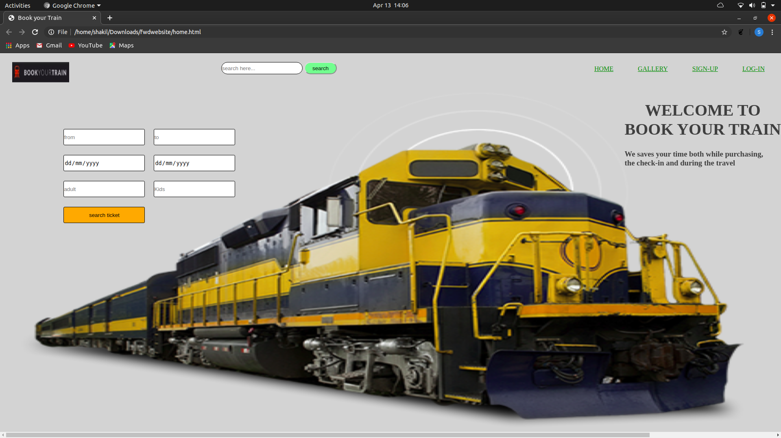



25

GALLERY

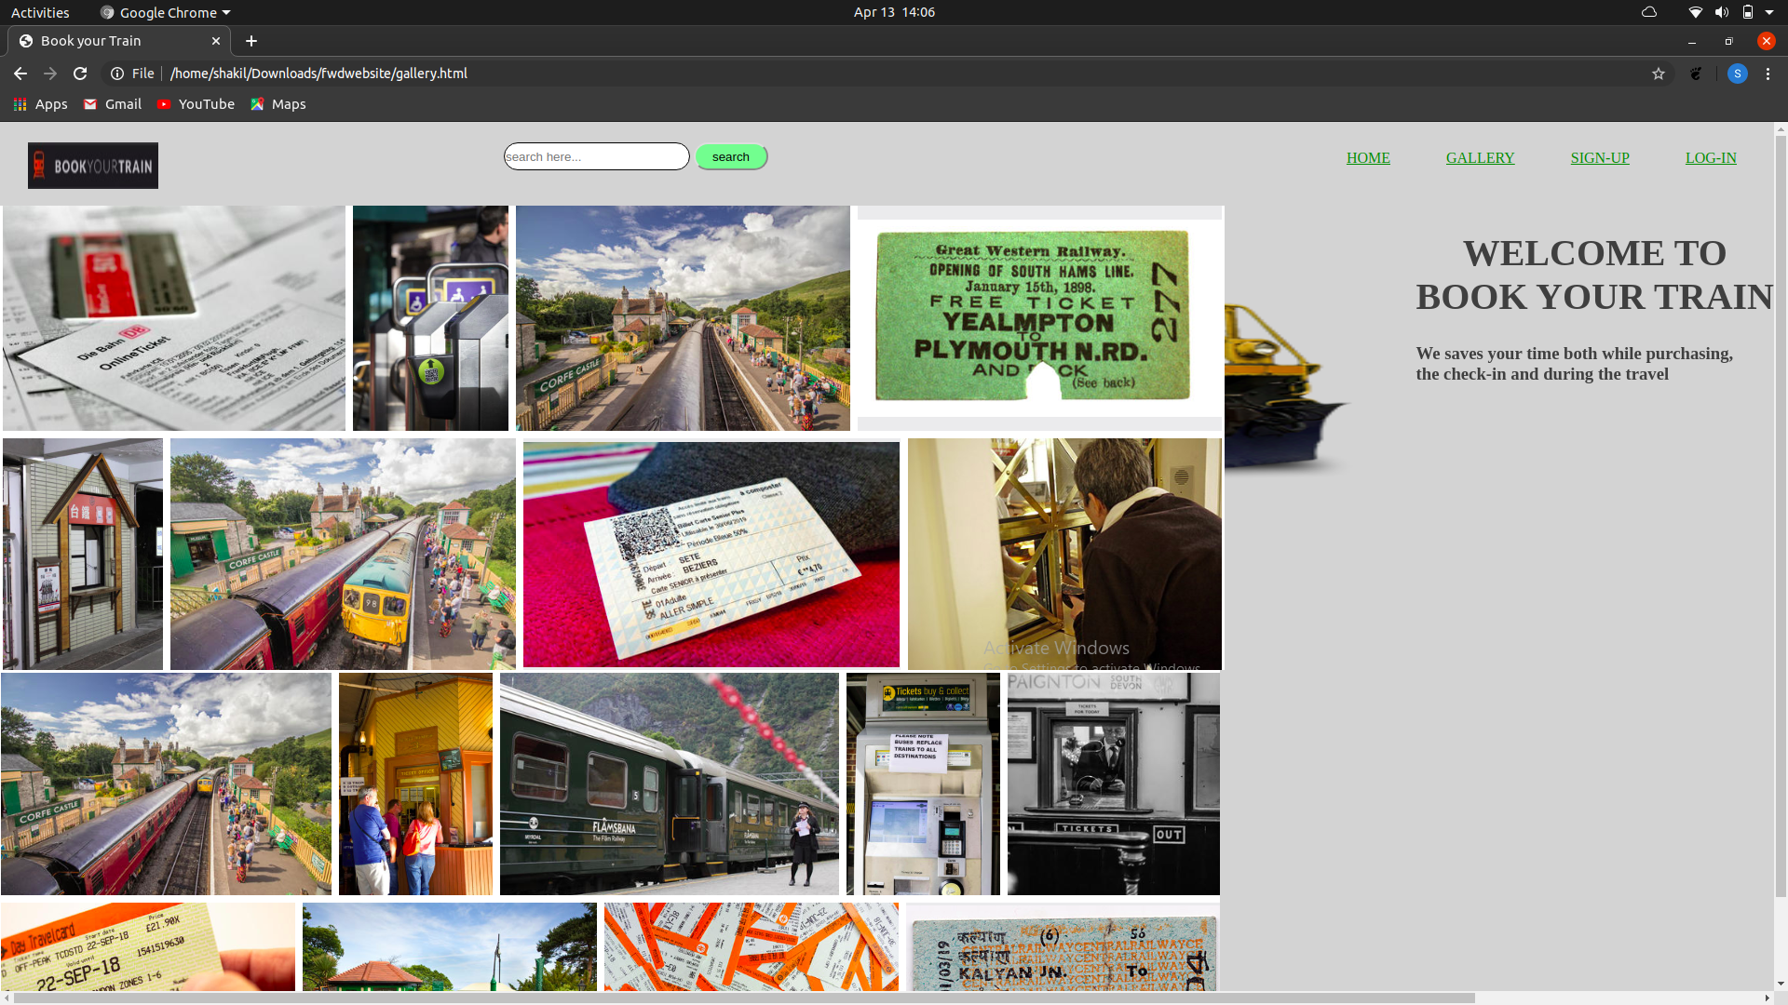

LOGIN PAGE

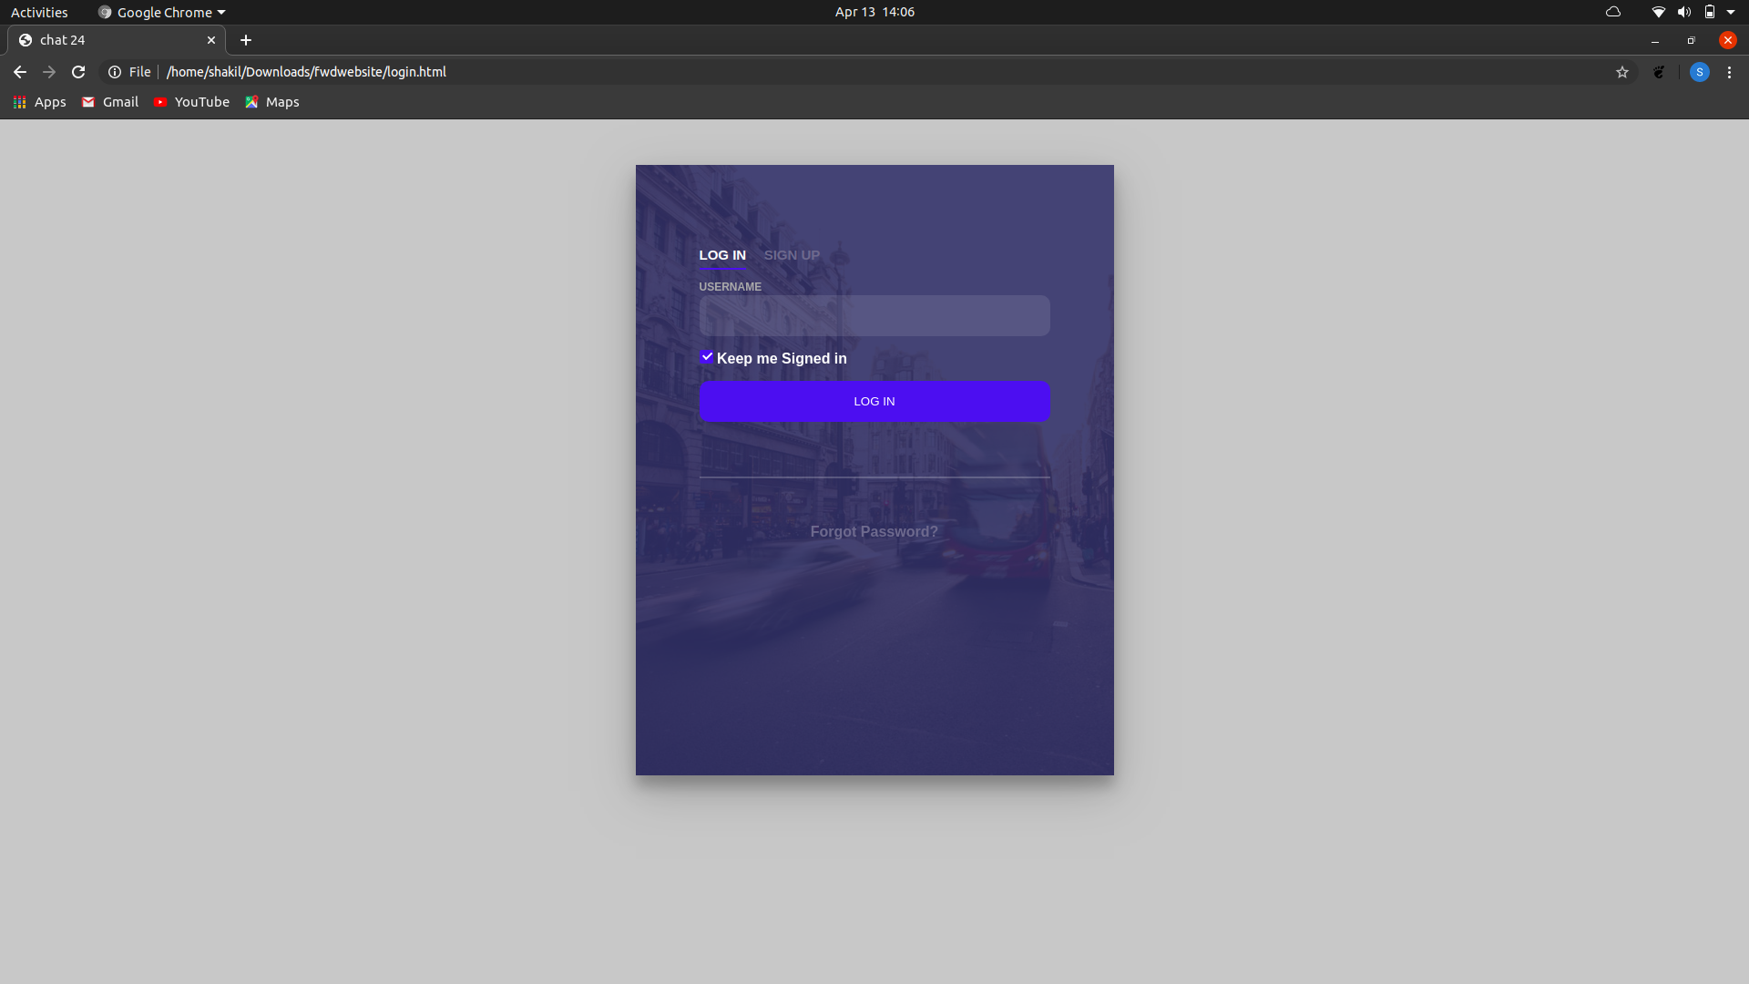

|  |  |
| --- | --- |
|  | **2012** |



**Conclusion**

Practical Training is a very important part of the curriculum as it strengthens the concepts and enhances knowledge about the practical implementation of all the theory concepts, we have learn so far in different subjects.

Our project is railway reservation system. This project is used to keep a track on reserving the seat to the passenger. It helps managing the system very efficiently and conveniently.

Although the project work has been done in a complete and detailed manner but due to the constraint of time, we could not include some more features we wanted to. We left these features as a part of the feature development. As soon as we’ll get time we’ll try to add them to my project.



|  |  |
| --- | --- |
| RAILWAY RESERVATION | **2012** |

**REFERENCES AND PLAGIARISM**

1. Book:=
   * Programming with C++ By Balaguru sami
   * HTML AND CSS MASTER
   * By Bharat & Co,

UDEMY

W3schools.com

Leetcode.com

1. Websites:=

* [www.google.com](http://www.google.com/)



Www.geeksforgeeks.org

Www.techdelight.com

ww.W3Schools.com (most helpful site)

5

|  |  |
| --- | --- |
| RAILWAY RESERVATION | **2012** |





36